Devil lives in the details.
Marx, Karl. [1969] 1976. “Chapter 2. The Process of Exchange.” Pp. 178–87 in Capital. A critique of political economy. Vol. 1. New York: Penguin Books.
Marx, Karl. [1969] 1976. “Chapter 3. Money, or the Circulation of Commodities.” Pp. 188–244 in Capital. A critique of political economy. Vol. 1. New York: Penguin Books.
Marx was tracing the determinants of the exchange process particular for the bourgeois society, in its initial conditions. Which begins with the social movement of commodities, by one side, and money in the other extreme of exchange relations.
The first distinction presented by Marx as a determinant of the exchange process of the bourgeoisie society is the differentiation between the commodity and the bearer. For the [bearer] his commodity possesses no direct use-value [[KV1C2P179L13]]. For himself its only direct use-value is as a bearer of exchange-value, and consequently, a means of exchange [[KV1C2P179L15]]. In the exchange process the capitalist as bearer of a commodity treats something that is not a use-value as an exchange-value, and fix its use as a mean for exchange while appearing in the process of exchange as if it would have the exchange-value form of commodities.
The second, is the determination of a universal equivalent as a consequence of the expansion of the exchange process. From the perspective of the individual, each of the bearers treats his own commodity in exchange as the universal equivalent for all other commodities.
The determinants of the exchange process are rooted in the history of the formal social movement of the commodities, because the exchange of use-values in upward scale-shift, requires a relative form of value reached by social accident by one commodity which is both commodity and money: gold, and also other precious metals in history, were fixed as universal equivalents [[KV1C2P180L24]].
The third one corresponds to the transformation of gold, the money-commodity, into monetarized capital. In the transition between the exchange of use-values, and the exchange of commodities, there is a determinant detail. And more than a detail, the particularity of the exchange process, an original mistake, a social accident, acted first then thought, to treat something, that is not for being appropriated as a commodity, as if it was a commodity.
The historical expansion and intension of the process of exchange is the process of taking everything that is possible as something (LCWV38P108L17) to appropriate, as if it was a commodity, with the purpose of appearing as its owner as an exchange-value, seeking to receive a equivalent exchange-value in the form of the most circulated exchange-value as mean of payment. And therefore, by the escalation of its compulsive subsumption over circulation as determinant of the: “need to give an external expression to this opposition [between use-value and value which is latent in the nature of the commodity] for the purposes of commercial intercourse produces the drive towards an independent form of value, which finds neither rest nor peace until an independent [value]form [“independent from its own use-value” [[KV1C2P182L34]]] has been achieved by the differentiation of commodities into commodities and money. The use-value of something is distinguished from its usefulness as a means for exchange [[KV1C2P187L9]].
Gold mining was already a branch of production centralized in the hand of capitalist production, before, during, and after the transition of mercantile capital into industrial and finance capital. So, the social accident of the expanded circulation of gold-money as capital and mainly the decision to use it as a means for exchange, as universal equivalent, is not an accident for the individual gold bearer who as bearer of the money-commodity want to exchange every other commodity avoiding alienating his money-gold in the process of exchange as an exchange-value.
"The difficulty lies not in comprehending that money is a commodity, but in discovering how, why and by what means a commodity becomes money." [[KV1C2P186L24]]
The process of exchange finishes in the realization of commodities as exchange-values. So, it is by consumption, which for the particular formation of interest (bourgeois society) is realized with the payment of the commodity price (C): as the magnitude of the general measure of the exchange value for every commodity produced by, for, and as, capital.
By the realization of the exchange process, the use-value produced as a commodity for capital reproduction can be appropriated or become something useful for the reproduction process of individuals in bourgeois societies.
Indeed, profit properly results from the consumption of the exchange-value price of those commodities produced under certain circulating capital expressed in a determinant, contingent, money form. Which is the universal equivalent commodity in generalized circulation or extended circulation, under a particular currency or money form, of generalized use as a means of payment for commodity circulation, under which the capital expenditure in the production of certain mass of commodity-capital took place, physically, which for the purpose of profit creation by capital reproduction, as a measure of the wealth of a society.
The scale of expanded reproduction increases territorially, with the colonial policy of imperialism, as a mean for the extension of capitalists production of commodity-capital for profit accumulation, by the colonization of the territories under other modes of production and distribution by appropriating the surplus-value of the commodity production mediated by money-capital form (have a price, a money value form), and realizing it as profit under a mode of distribution in which the exchange value is realized under the money-form currency (fraction of an universal equivalent commodity) correspondent to the capital on which profits are accumulated. So, European mercantile capital reproduced by colonial mining, mainly silver. But with the silver they bought gold, dominating directly its exchange value, and indirectly reducing the exchange-value measure of the transactions occurring under the production and circulation of commodities realized using silver and copper, as the money-capital form or expression of exchange-value mainly demanded in China during the period mentioned and during the second part of the XIX century [[KV1C3P191FL13]].
In that manner, gradually, the money exchange value form (M) became the expression or symbol of the money-commodity (gold) price (G), so the specific equivalent (weighted gold, W) became universal equivalent (G). Within a concrete, exchange relations set, or exchange process, the form of expression of the total magnitudes in exchange are fixed by two quantitatively comparable expressions of exchange-value, money-capital (M) and weighted gold (W), in two qualitatively equal measures, as exchange value price measured in money (M) or gold money-commodity price (G). So, four possible universal equivalents: abstract labour time (L), gold weight (W), commodity-money price (G), money price of every commodity (C), at least, exists for the purpose of exchange commodities produced by certain capital and realized in the circulation of another capital,
Indeed, the exchange of gold is determined by its social movement and the form of its distribution. The appropriation of the surplus-value of gold-mining production (W) during mined gold circulation, as profit realized by its consumption with the purchase of gold by money (M), or by its hoarding as monetary reserves in its weighted elementary form (W) which is also bearer of an exchange value distinct from its money price or money form of commodities [[KV1C3P189L21]], as gold have its own qualitative equalized expression signed by the commodity-money price of gold (G) [[KV1C3P190L9]].
Gold is then not money but the commodity-money in which the magnitudes expressed as money quantities also must be denominated by its specific equivalent, elementary expression of their exchange-value form, as a fraction of commodity-money, as W: gold weighted, as quantitatively comparable expression for its money price, and for its commodity-money-gold price (G) (which is different than the expression of direct exchange of gold as a use-value: 1 gold Oz = 1 motorcycle, which is a passive form of value, contained by the mediation of money in the determination of its exchange value price (1 gold Oz = 2744.62 USD or 1 gold Oz = 19,556.90 CNY).
Marx thought:
“If therefore two different commodities, such as gold and silver, serve simultaneously as measures of value, all commodities will have two separate price-expressions, the price in gold and the price in silver, which will quietly co-exist as long as the ratio of the value of silver to that of gold remains unchanged, say at 15 to 1. However, every alteration in this ratio disturbs the ratio between the gold-prices and the silver-prices of commodities, and thus proves in fact that a duplication of the measure of value contradicts the function of that measure [[KV1C3P190L19]. [T]he slight and transient fall in the value of gold compared with silver, which was a consequence of the Indian and Chinese demand for silver, produced on a far more extended scale, its expulsion from circulation by gold [[KV1C3P191L12]]. […] All the experience of history in this area can be reduced simply to this fact, that where two commodities perform by law the functions of a measure of value, in practice only one maintains that position” [[KV1C3P191FL20]].
At present, the historical juncture appears as critical. The BRICS Summit of state leaders, and the IMF and World Bank annual meeting, will take place on Kazan and Washington respectively, one week before the November 5th, 2024, U.S. presidential elections. The hegemony of the U.S. dollar over the financial system as a target, defines a situation that can require a different solution. Like the treatment of gold as two different universal equivalents, defining two scales of circulation defined by the Chinese gold adding the gold reserves of Russia in a different gold reserve than the IMF SDRs, and by implication the remaining circuit of circulation of American and European capitalists will be significantly reduced, diminishing the price of the USD, with a detrimental effect on its rates of surplus value, profit and super-profit, because of its displacement by the Chinese Yuan (CNY) as universal equivalent, and by weighted Chinese gold as its specific equivalent, in the economies with significant circulation of CNY. The results of both meetings tend to a determination, by institutional change, of the world political economy of imperialism, in its international division of labor, in the geoeconomic war on Gaza and Ukraine, and impact the results of the U.S. ballot.

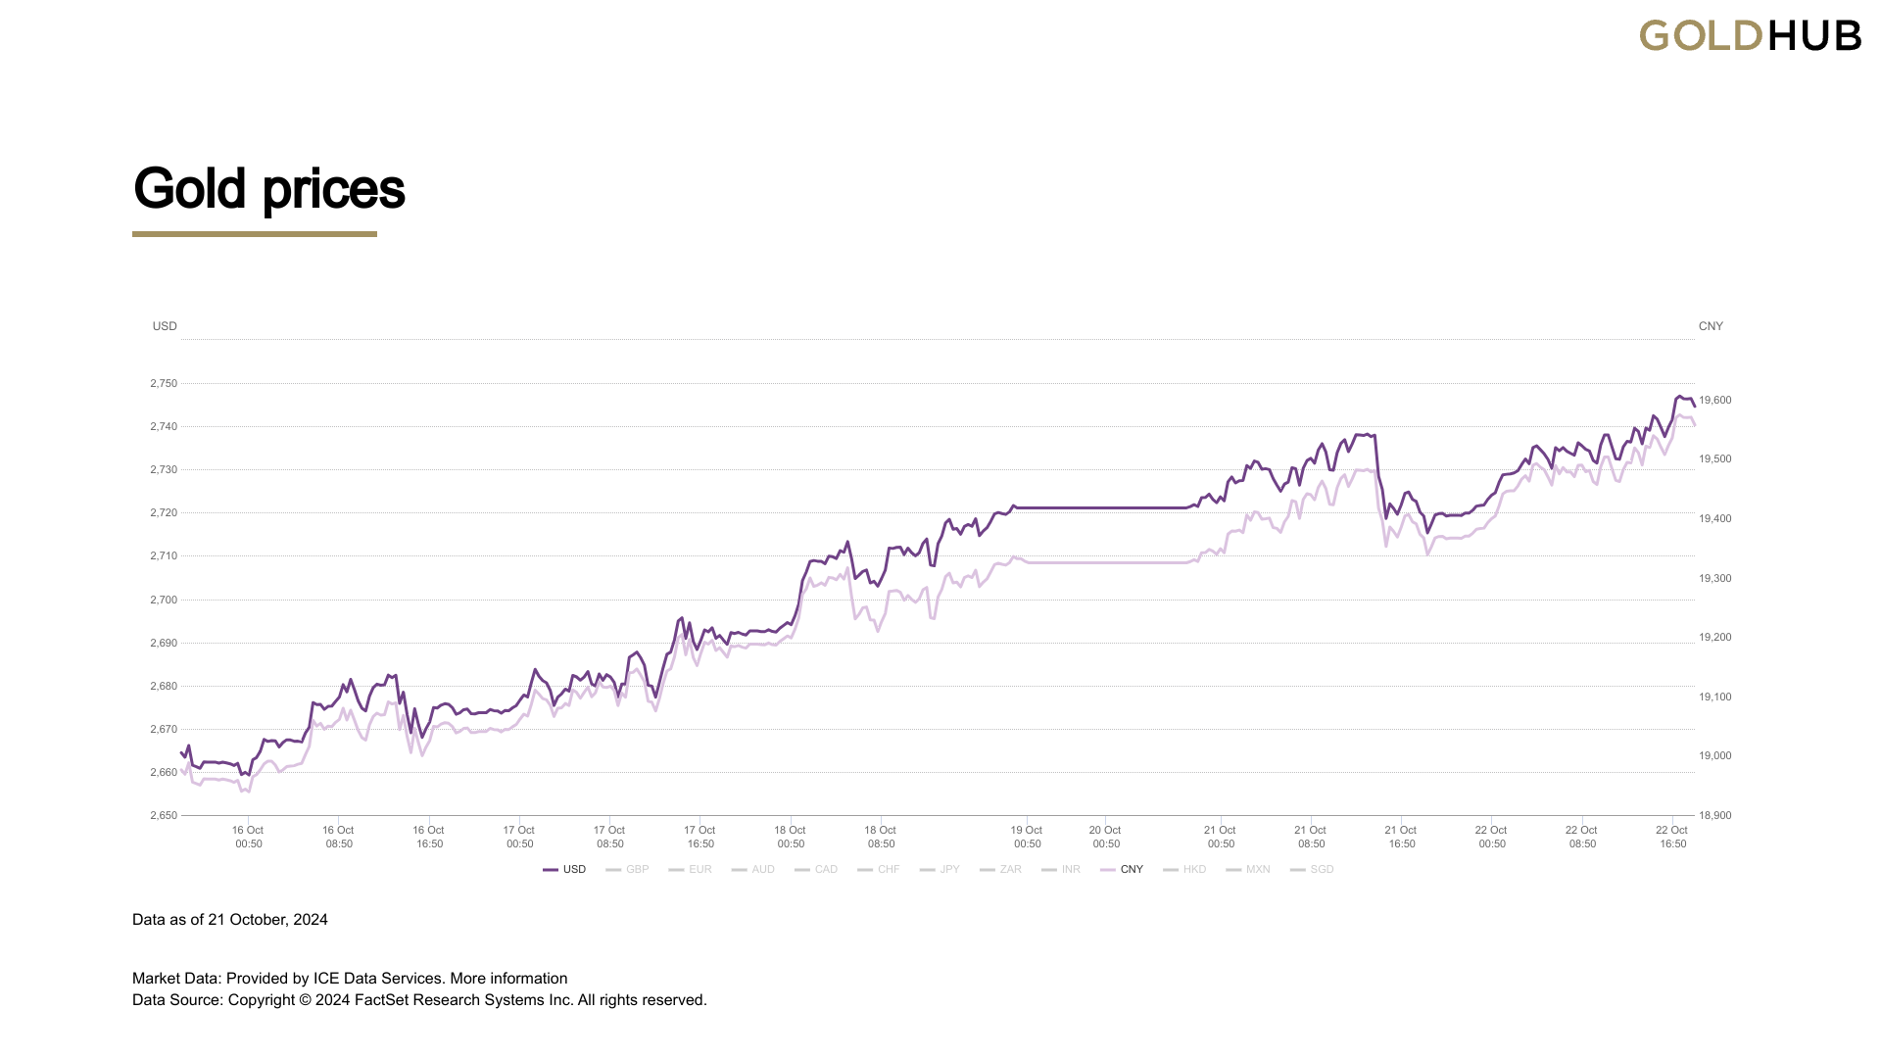
Figure 1. Historical gold prices since January 2, 1980 to October 22, 2024 in USD and CNY.

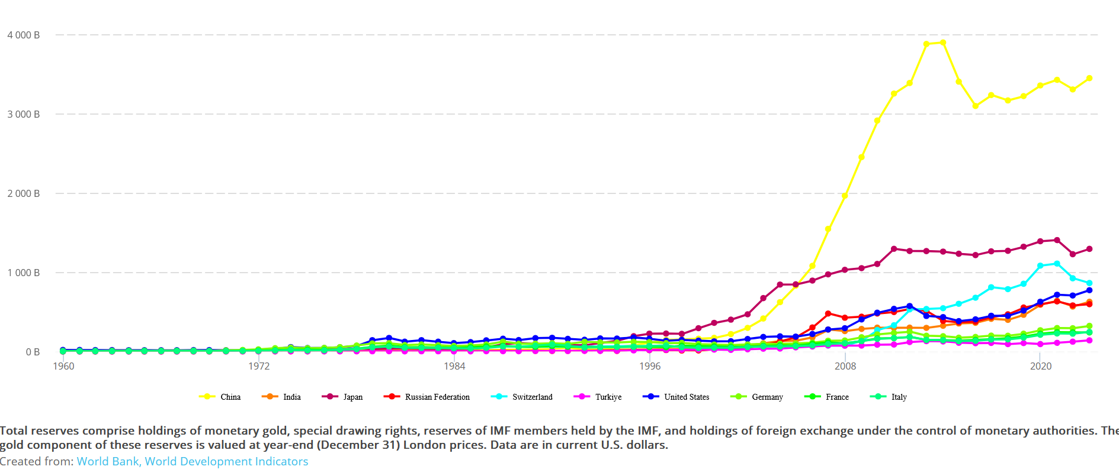
Figure 2. Total monetary national reserves measured in USD for the ten main gold hoarding states, 1960-2023.

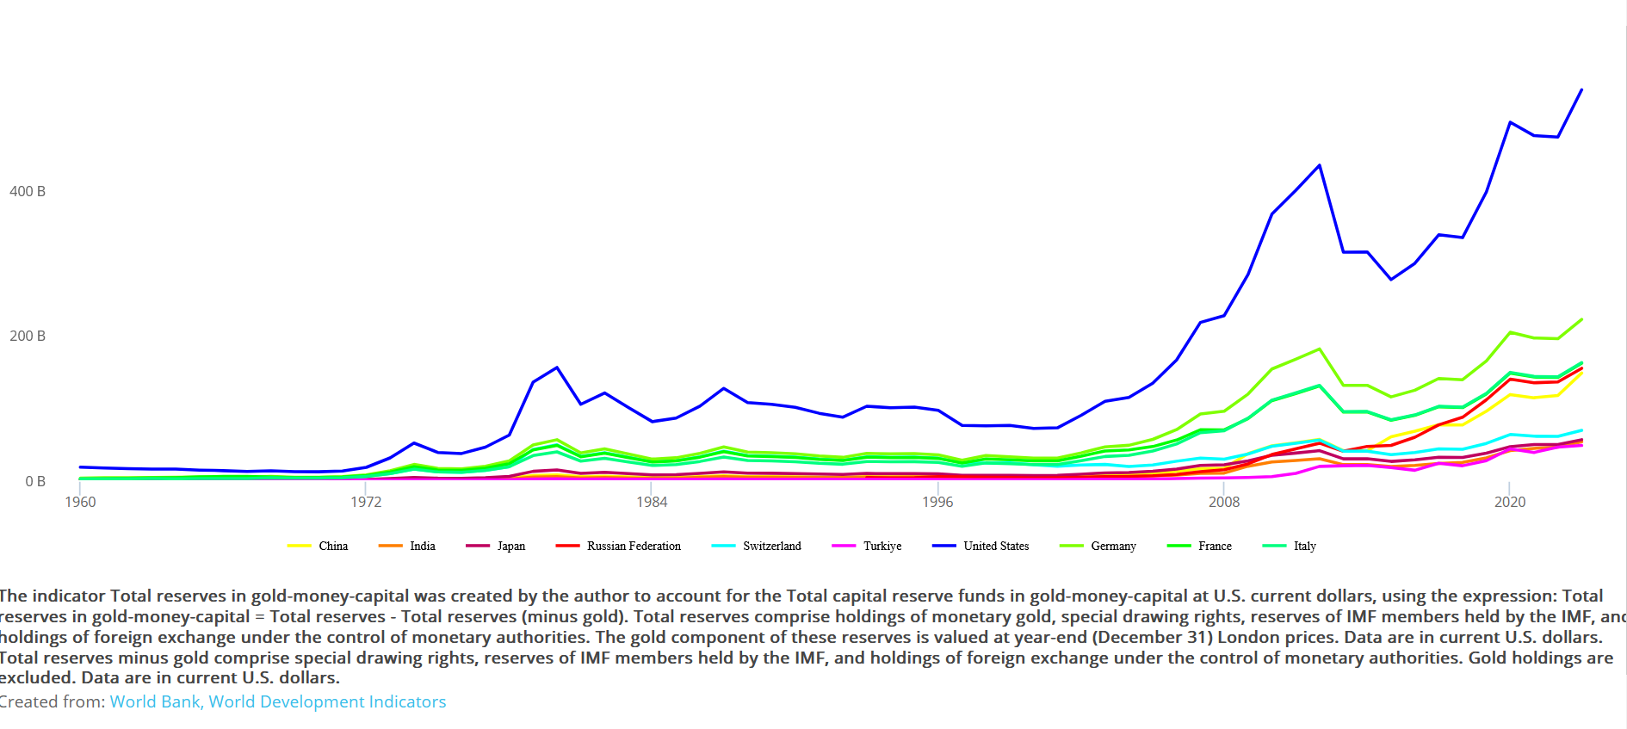
Figure 3. Total gold national reserves of the ten main gold hoarding states, 1960-2023.

